20. Develop a system using UML for Library Management System. It should verify the details of the reader by the central computer. The details regarding the reader will be provided to the central computer through the administrator in the library and the computer will verify the details of the reader and provide approval to the office. Then the books that are needed by the reader will issue from the library to him.

**Activity Diagram :**

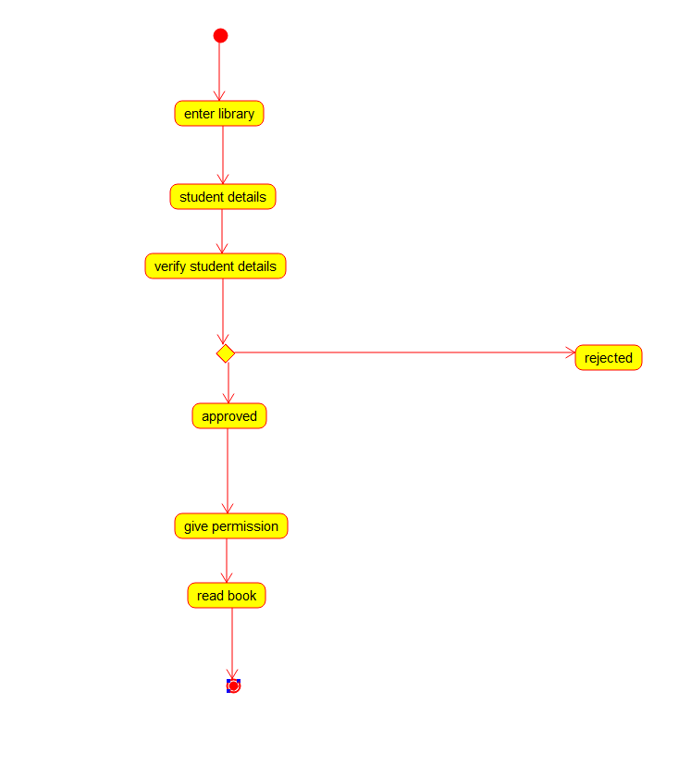

**Component Diagram :**

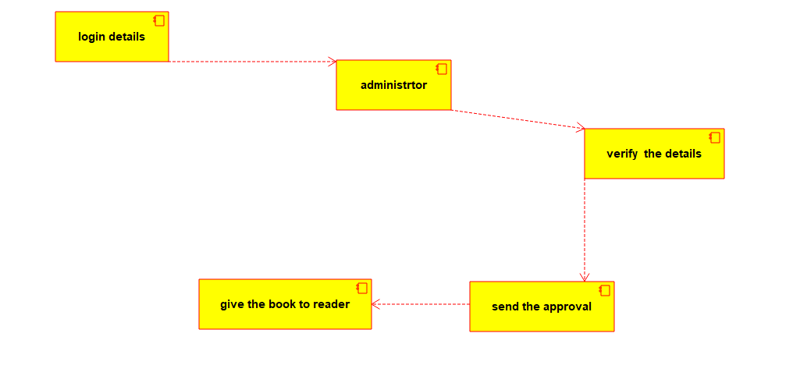

**Package Diagram :**

